Microsoft Graph Explorer Guide for M365 Group Creation Restriction

Microsoft Graph Explorer: Guide for M365 Group Creation Restriction

Official Casa Familiar Configuration Values
The specific IDs needed for the setup have been pre-filled in the JSON code blocks below. You do not need to hunt for IDs manually. Simply copy and paste the values exactly as shown.
- Security Group ID (SharepointSiteCreators): 4744bdd7-cf8e-40fe-b955-3759b0d39bd9
- Template ID (Group.Unified): 62375ab9-6b52-47ed-826b-58e47e0e304b
- Configuration ID (Active M365 Tenant Rule): 90faf456-6ace-401a-a44e-8954f0d54945

Note
Fast Track: Adding Exceptions to an Already Blocked System
If your Office 365 tenant already has a general restriction blocking everyone from creating sites, you can skip directly to Step 6: Update an Existing Configuration (The Correct Method). The configuration ID and group exception ID have already been baked into the code for you.
This guide provides a highly detailed, non-technical walkthrough to restrict Microsoft 365 Group creation (which also blocks Teams and SharePoint site creation) using the Microsoft Graph Explorer.

Step 1: Access and Login to Graph Explorer
Navigate to the following website:
https://developer.microsoft.com/en-us/graph/graph-explorer
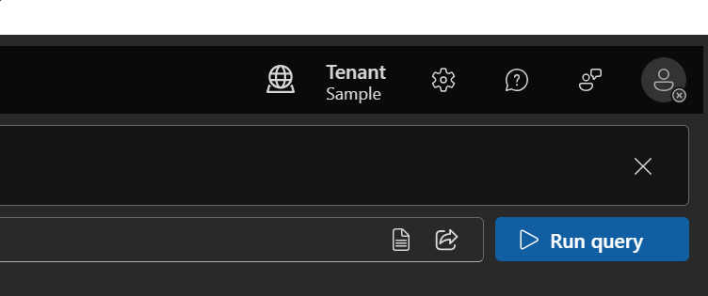
Image: The main landing page of the Microsoft Graph Explorer.
Click on the "Sign In" button on the left side menu to authenticate with your administrator account.
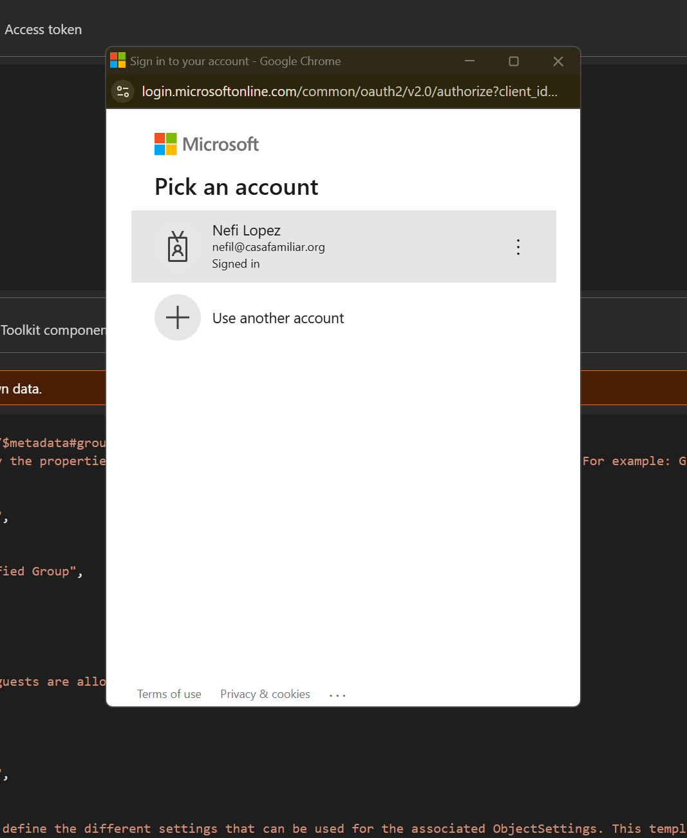
Image: The Sign In button located on the top left corner.
After successfully logging in, your profile picture and account name will appear on the left, and the workspace will be ready to execute commands:
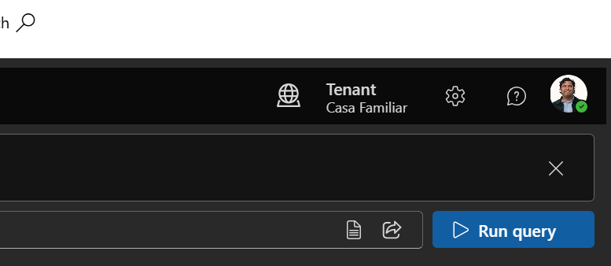
Image: The Graph Explorer interface after a successful login, showing your account details on the left pane.

Step 2: Get the Security Group ID (Optional)
In our case, the ID is already calculated (see Top Info).
If you need to verify it manually, in the Graph Explorer address bar at the top, execute the following GET query:
GET https://graph.microsoft.com/v1.0/groups?$filter=displayName eq 'SharepointSiteCreators'
Locate the "id" field in the response at the bottom.
Our ID is correctly confirmed as: 4744bdd7-cf8e-40fe-b955-3759b0d39bd9
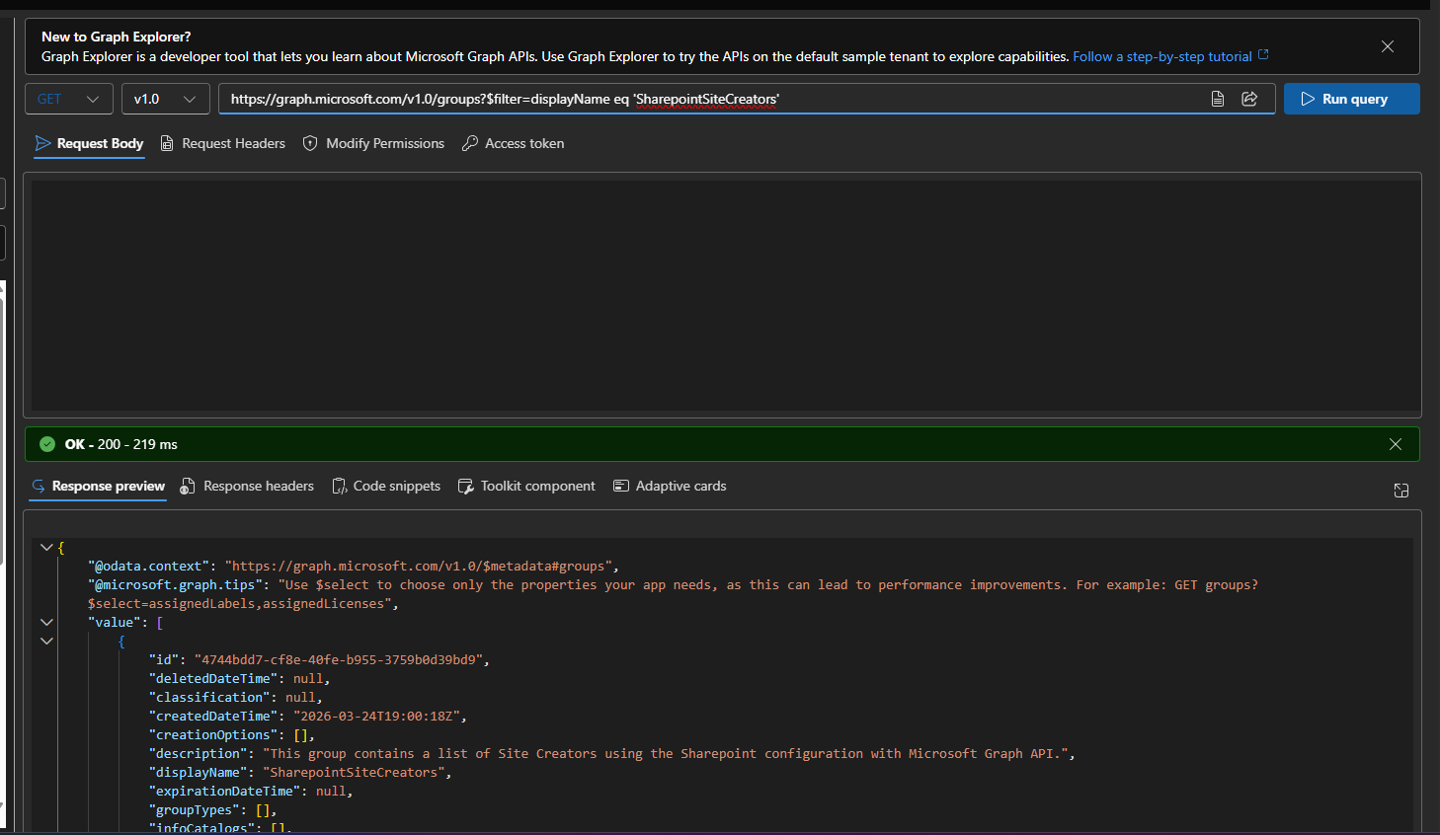

Step 3: Get the Correct Setup Template (Optional)
In our case, the Blueprint Template ID is already known.
If validating manually, call this endpoint in the address bar:
GET https://graph.microsoft.com/v1.0/groupSettingTemplates
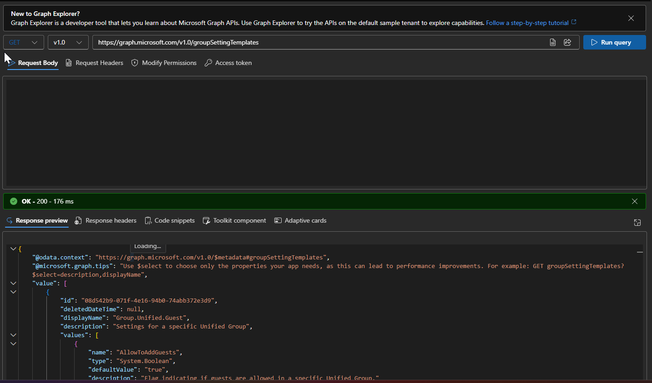
Locate the block named exactly "Group.Unified".
Our Template ID is correctly confirmed as: 62375ab9-6b52-47ed-826b-58e47e0e304b

Step 4: Check if a Rule is Already Applied
Check if the organization already has a configuration created from that template.
Execute this in Graph Explorer:
GET https://graph.microsoft.com/v1.0/groupSettings
If your screen returns an empty "value": [], proceed to Step 5.
If it returns a configuration for Group.Unified, verify that its id matches our predefined Configuration ID: 90faf456-6ace-401a-a44e-8954f0d54945. Then proceed directly to Step 6.
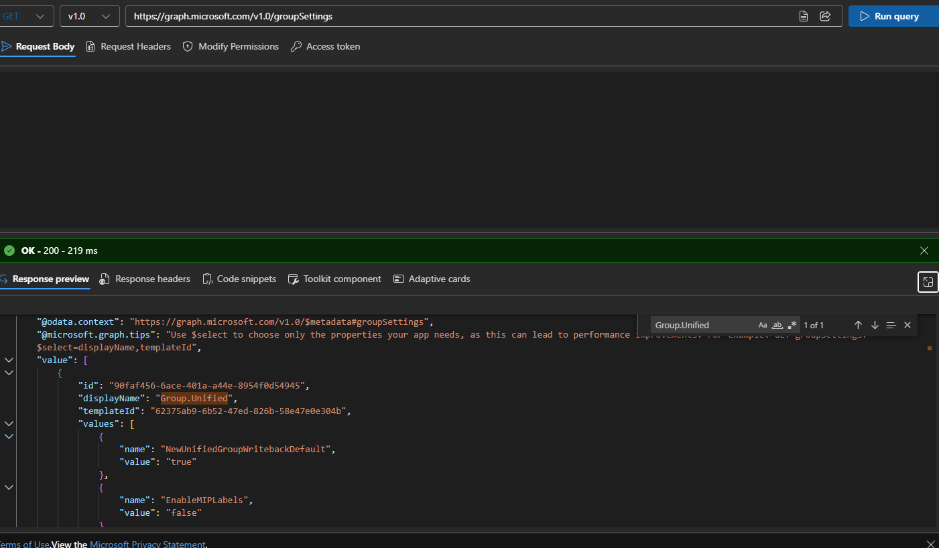

Step 5: Create a New Configuration
If no previous configuration exists, change the method dropdown to POST and execute:
POST https://graph.microsoft.com/v1.0/groupSettings
In the "Request body" tab, paste the following JSON EXACTLY AS SHOWN (it already contains our official IDs, no editing required):
{
"templateId": "62375ab9-6b52-47ed-826b-58e47e0e304b",
"values": [
{ "name": "EnableGroupCreation", "value": "false" },
{ "name": "GroupCreationAllowedGroupId", "value": "4744bdd7-cf8e-40fe-b955-3759b0d39bd9" }
]
}
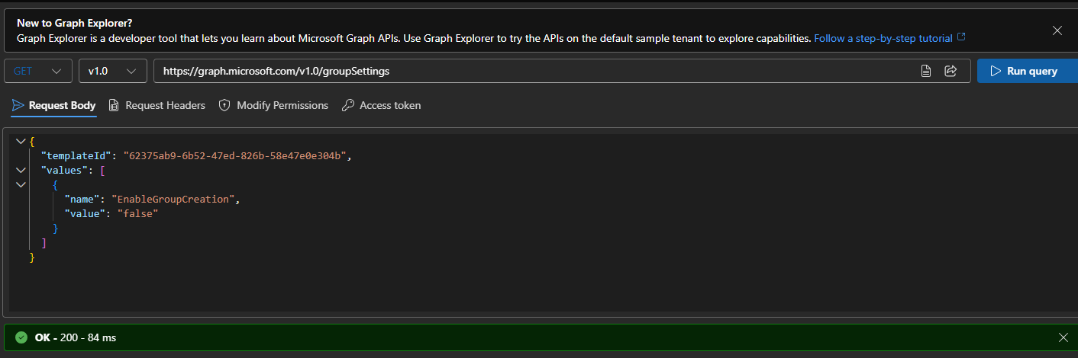
Image: Executing the POST request with the JSON payload in the request body.

Image: The successful response after creating the new configuration.

Step 6: Update an Existing Configuration (The Correct Method)

Important
Why Update (PATCH) instead of making a new one?
Microsoft only allows ONE saved rule for group creation in the entire tenant. The safest practice is to take the existing rule and "inject" the exception into it.
Follow these EXACT steps to add the Leadership Group as an exception to our existing configuration:

1. Change the Method to PATCH
At the top left of the Graph Explorer address bar, select PATCH from the method dropdown list.

2. Type the Exact URL Address
In the address bar, paste the following exact path (which includes our official Casa Familiar Configuration ID pre-filled for you):
https://graph.microsoft.com/v1.0/groupSettings/90faf456-6ace-401a-a44e-8954f0d54945

3. Prepare the "Request Body"
Below the address bar, find the tab labeled "Request body". Click on it, clear everything inside, and paste the exact code below.
This tells Microsoft: "Block everyone (false), EXCEPT our SharepointSiteCreators group":
{
"values": [
{ "name": "EnableGroupCreation", "value": "false" },
{ "name": "GroupCreationAllowedGroupId", "value": "4744bdd7-cf8e-40fe-b955-3759b0d39bd9" }
]
}

4. Execute the Command
Press the large blue button "Run query".
If successful, the bottom screen will show No Content - 204. Congratulations, the rule has been applied!

Step 7: Verification Process
To ensure everything took effect, run:
GET https://graph.microsoft.com/v1.0/groupSettings
Check the response values to confirm the block is active:
- EnableGroupCreation = false
- GroupCreationAllowedGroupId = 4744bdd7-cf8e-40fe-b955-3759b0d39bd9

Step 8: How to Revert the Restriction
If you ever need to lift the ban and allow all users to create groups/sites freely again:
- Change the method to PATCH and use this exact URL:
https://graph.microsoft.com/v1.0/groupSettings/90faf456-6ace-401a-a44e-8954f0d54945
- In the Request Body, send this payload to toggle creation back to true:
{
"values": [
{ "name": "EnableGroupCreation", "value": "true" }
]
}
- Click Run Query.

Step 9: Field Test Verification
To confirm the block works for regular users, perform these tests with a non-admin account:

Test 1: Microsoft Teams
- Log into teams.microsoft.com.
- Navigate to the "Teams" tab. The "+ Join or create a team" button should not allow creating new teams.

Test 2: SharePoint Online
- Log into SharePoint. The "+ Create site" button should be hidden or disabled.

Test 3: Outlook Web
- Log into outlook.office.com. The option to create a "New group" should not appear.

Test 4: Administrator Check
- Log into the M365 Admin Center with an Admin account.
- IT administrators can still provision groups securely from here.

